International Conference
on Ageing & Health

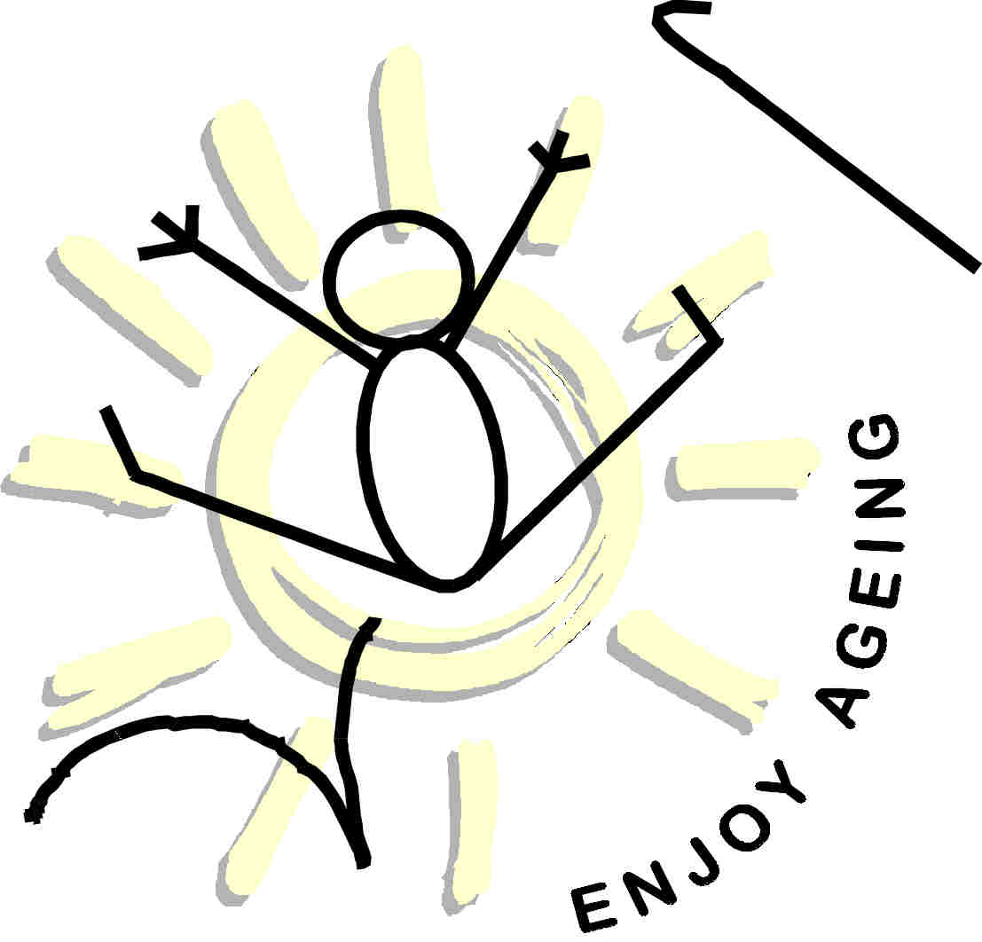

Capacity Building for Ageing Societies!
Porto, Portugal
1-6 August, 2000

Secretariat :  Rua Calouste Gulbenkian, n 53, 5 P, H1  4050-245-Porto-Portugal  Tel: +351-226063141  Fax: +351-222080291  E-mail: ageingcf@hotmail.com  Http://welcome.to/ageingcf | 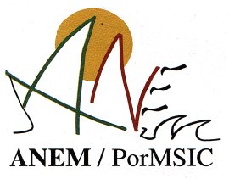
 | 

